Adventitious shoot regeneration from in vitro leaves of several apple cultivars (Malus domestica Borkh.)

Robert SMITH¹, Peter C. WILLIAMS²*, Jennifer TOTH²…

¹University of Western Australia, Faculty of Natural and Agricultural Sciences, 35 Stirling Highway Crawley, WA 6009, Perth, Australia; rsmith2000@yahoo.co.aus
²Curtin University of Technology, School of Public Health, Division of Health Sciences, Selby Street, WA 6008, Shenton Park, Australia; pwilliams@gmail.com (*corresponding author); jenniftoth@yahoo.co.aus

Abstract

The abstract should be a concise and self-explanatory summation of the findings from the paper, presented in one-paragraph, without citations, abbreviations or footnotes. The abstract should count 200-250 words and have a structured form, e.g. reflect the structure of a study (background, material and methods, results, conclusion). The abstract must reflect the content of the article, as for most readers it will be the major source of information about the study. It must contain all necessary information and data of the full paper (the information in the abstract also appears in the main body of the article). Abstract, together with the title of the paper, is a source of data for indexing journals and thus important for quotation of the paper by other authors. In the research articles, the abstract should be informative, including actual results. Only in reviews should the abstract be indicative, i.e. listing the major topics discussed, but not giving outcomes. Even though the results should represent the most important part of the abstract in the original articles, start the abstract by explaining very briefly the background of the research (why the study was needed/why the topic is interesting?) and then summarize the research material and method. After the results, at the end, highlight what you found as major data and relationships, respectively your interpretation and/or the main consequences of your findings (conclusions/usefulness/originality). Abstract and full text of the paper will be written in an impersonal mode, past tense; eventually, reserve the present tense for generalizations.

Keywords: breeding; genotypes; scab resistance etc. (five to seven key words in alphabetical order)

Introduction

Generalities. The manuscripts should be typed with Garamond Premier Pro using this template (A4 paper - European format, 210 × 297 mm, top margin: 25 mm; bottom margin: 35 mm; right and left margin: 25 mm), line and paragraph spacing 1. The text (paragraphs) will be edited wholly in justify alignment, font size 11, except title, authors, institutions and other particular aspects, e.g. tables and figures, references (see this model), single line spacing. Indent each section, subsection and line of a new paragraph one-tab space, which should be set at 1.00 cm.
Between lines/rows with spaces (free lines), there are used Garamond Premier Pro font size 11, no italics and no bold, as follow: two lines above and one below the title of manuscript; one line below the list of authors; one line below the institutions; two lines above each chapter and one below the title of chapter; one line above subsection titles; one line above and below the tables and figures.
There are four categories of submissions (types of manuscript): ‘Research articles’ (or ‘Original articles’), ‘Note’ (or ‘Short research articles’), ‘Review articles’ (including ‘Short review articles’), ‘Editorial’. The scientific content of the original manuscripts (‘Research articles’) will be elaborated so as to be structured (if possible) comprising: ‘Introduction’, ‘Materials and Methods’, ‘Results’, ‘Discussions’, ‘Conclusions’, (‘Authors Contributions’; ‘Acknowledgment’; ‘Conflict of Interests’), ‘References’. All these sections will be aligned left and typed in Garamond Premier Pro font size 11, bold.
The papers will be written in an impersonal mode. First person is possible, but it should be used sparingly. Please reserve the use of first person for things that you want to emphasize that “you” uniquely did.
Title (Garamond Premier Pro 16, bold, Center alignment). The ‘Title’ of the manuscript should be concise (no more than three typeset lines, generally less than 140-150 characters including spaces), accurate (unambiguous), informative (including the organism studied), understandable to specialists in other fields, and must reflect the content of the article. Where possible, avoid abbreviations, formulae and numbers. The following should also usually be omitted: “Investigation of ...”; “Study of ...”; “More about ...”; “... revisited”. The title is written with small letters, except initial of the first letter and proper nouns, or other specific characters.
Author(s) (Garamond Premier Pro 16, not bold, Center alignment). List the full names of all authors in the order intended for publication, using. Use superscripts to match authors with institutions. Use capital letters for family name of each author, initial for the middle name, small letters for their first/given name, except the first letter of the first name which is capitalized. Please give below full contact data for all co-authors.
Institution-affiliation (Garamond Premier Pro 9, italic, Center alignment). The affiliation should be provided in the following order: university/institution name, faculty/department name, address, city, country; after country and semicolon (‘;’), email address of each co-author is obligatory (if possible, use institutional e-mail for all authors).
Use numbers as superscripts to match authors with institutions, immediately after the author’s name, without space. After the author’s name, use Asterisk (*), not as superscript, to designate the corresponding author (please note: only one corresponding author is allowed). Only if necessary, use lowercase letters, as superscript immediately after the institutional number, to illustrate the equal contribution of some authors (e.g. Robert SMITH^{1a}, Peter C. WILLIAMS²*^{b}), which will be mentioned below, under institutional address, in a separate line, as (e.g.): “^{a,b}These authors contributed equally to the work”).
Abstract (Garamond Premier Pro 11, justify). See above all the details, e.g. “The abstract should be a concise and self-explanatory summation of the findings from the paper, presented in one-paragraph, without citations, abbreviations or footnotes. The abstract should count 200-250 words and have a structured form, e.g. reflect the structure of a study (background, material and methods, results, conclusion)” etc.
Keywords. Use five to seven key words in alphabetical order separated with semicolon (‘;’), without period at the end. Include all relevant scientific terms that are absent from the title and/or abstract.
Abbreviations. Include this section after ‘Keywords’ only if is necessary. Define abbreviations from the article in alphabetical order (separated with semicolon), except those obvious to non-specialists.

METADATA. To ‘Principal contact for editorial correspondence’ (the author who uploaded the submission): Please fill in METADATA journal e-platform (“Submission”, “Metadata”) properly all necessary boxes, e.g. “Section” (e.g. ‘Research Articles’), “Title”, “Abstract”, “Keywords” and “List of Contributors” identically with the latest version of the manuscript [IMPORTANT: All e-metadata fields have to be similar with the manuscript data!]. Use “List of Contributors” in order to “Add Contributor” – including properly orders of all authors. “Given name” (e.g. John; please use capital letters only for initial letter, ‘J’); you can include in this box also the middle name or only initial(s), e.g. John Bryan, or John B. etc. “Last name” (e.g. SMITH; please use capital letters only for family name). Do not complete “Preferred Public Name” field! “Email” (e.g. j_smith@ucla.com; if possible, please use institutional email address). “ORCID iD” (only for author who already has assigned by the ORCID Registry; in this case, include the full URL (e.g. http://orcid.org/0000-0002-1825-0097). “Affiliation” (the affiliation should be provided in the following order: university/institution name, faculty/department name, address). “Country” (please chose and insert by clicking right country for each author). “Bio Statement (E.g., department and rank)” [Not necessary! Please do not complete this field]. In the “References” section, please separate individual references with a blank line, >Enter<].

Introduction. The ‘Introduction’ chapter (section) must summarize properly the relevant literature, so that the reader can understand why the topic is important, interesting and why the authors were interested in this research. Do not include information that is not relevant to your research question(s) stated in the introduction. The authors are invited to establish the context of the accomplished work by discussing the relevant primary research literature (with adequate citations) and summarizing the current understanding of the investigated problem. Generally, every statement in introduction must be accomplished by citations and the authors must give properly the background of the study, using especially up to date references.
The reviewed literature must be related to the topic of investigation question, and the most relevant resources will be cited and listed properly as references, according to journal style. Please try to provide relevant citation(s) to the source: international, accessible data (by academic databases), significant, credible and recognised (through peer reviewed system and citations), adequate and timely. Focus your efforts on the primary research journals - the journals that publish original research articles. Although you may read some general background references (encyclopaedias, textbooks, manuals, etc.) to get yourself acquainted with the subject area, do not cite them, because they contain information that is considered fundamental or “common" knowledge within the discipline. Cite, instead, articles that reported specific results relevant to your study, based especially on peer reviewed journals.
Examples of citations in the text, depending on the number of authors in the cited papers: one author (Smith, 2019), two authors (Johnson and Miller, 2020), more than two authors (Anderson et al., 2017). To cite multiple sources in the same parenthetical reference, separate the citations by a semi-colon; e.g. (Robbins et al., 2017; Jones, 2018; Brown et al., 2019). As it turns out, citations should be listed in chronological order, e.g. (Gibson, 1999; Davey et al., 2014; Robson et al., 2015). Please edit ‘et al.,’: use italics for ‘et al’ but not the period and comma which should be written regular. The citations can be positioned at the beginning, middle or end of a sentence, as in the next examples: “Cooper (2001) demonstrated the effect of ecological conditions on the diseases attack. Interpreting these results, Williamson (2003) suggested that…”; “Simson and Wood (2015) reported an increase in the number of diseases, whereas Pratt et al. (2011) reported a decrease; the most intense attacks were found on the leaves (Stanley et al., 2020)”.
Using appropriate arguments and references, the authors must explain why the study was needed and at the end of the introduction specify clearly the research objectives or the question(s) their aimed to answer. This presentation starts usually from general more issues and gradually focuses on specific research question(s). Why is the research interesting? Discuss the significance of the research (importance, topical). State the purpose of the work in the form of the hypothesis, question, or problem you investigated.
Try to end your ‘Introduction’ with a paragraph describing clearly your aim (research question), well linked/correlated with information that already you provided. Try to change the wording enough or add a few details to keep it interesting (not formal) and well argued. Briefly explain the aim of the study, the logic behind the experimental setup, your rationale and approach and, whenever possible, the possible outcomes your study can reveal.

Materials and Methods

General information about M&M chapter (section)
The M&M section of a research paper provides the information by which a study’s validity is judged. Therefore, it requires a clear and precise description of how an experiment was done and the rationale for why specific experimental procedures were chosen. This section should describe what was done to answer the research question, describe how it was done, justify the experimental design and explain how the results were analysed. Therefore, its structure should: describe the materials used in the study, explain how the materials were prepared for the study, describe the research protocol, explain how measurements were made and what calculations were performed and state which statistical tests were done to analyse the data (Kallet, 2004).
Organize your presentation of M&M so that readers will understand the logical flow of the experiment(s). Describe in detail how the study was carried out (e.g. study area, origin of analysed material / biological material, sample size, number of measurements, data collection, criteria, equipment, data analysis, statistical tests, software used). Therefore, the chapter M&M should be written in logical and explanatory sequences (using subheadings of the chapter, no more than 4-5 but each of them with enough consistency). That means your M&M section should be crafted / structured to follow the logical work and sequences order needed to answer to the investigated questions/hypotheses. Please do not forget: methods should be detailed enough to permit replication of the work (there should be enough information in M&M to allow another scientist to repeat your experiment). Please give enough information to indicate how the research was conducted. The description of preparations, measurements and the protocol should be organized chronologically. Well-known tests or procedures should be cited, but not described in detail. If you cite a method described in a non-English or inaccessible publication, explain it in detail in your manuscript. In addition, all factors that could have affected the results need to be considered. Avoid names of brands or commercial products, instead state clearly the active ingredient, chemical formula or purity.

Subsections
Subheadings of M&M, respectively subchapters or subsections (written as in this model, using italics, no bold) work well for this purpose, e.g. ‘Description of the study site’; ‘Biological material’; ‘Experimental‘ or ‘Sampling design’; ‘Experimental procedures’ or ‘Protocol for collecting data’; ‘Qualitative analysis’ and/or ‘Statistical procedures’ etc.
If in a sub-section i.e. as ‘Description of the study site’ it is necessary or relevant for a better understanding to add a map (which should be numbered as a figure in the article, e.g. Figure 1), please do not include a satellite image or third-party maps, including any images generated by Google software (Google Maps, Street View, and Earth), due copyright restrictions. Please supply a replacement figure using software compatible with our CC BY 4.0 license (http://creativecommons.org/licenses/by/4.0/) and please state the source of the new image in the figure caption. If the content of the manuscript depends on the use of Google software, you may need to provide replacement images that are representative of the Google-generated images. Please check the copyright information on all replacement figures. If applicable, please specify in the figure caption text when a figure is similar but not identical to the original image, and is therefore for representative purposes only. The following alternative resources are available for replacing copyrighted map figures: USGS National Map Viewer (public domain): http://viewer.nationalmap.gov/viewer/; The Gateway to Astronaut Photography of Earth (public domain): http://eol.jsc.nasa.gov/sseop/clickmap/; USGS EROS (Earth Resources Observatory and Science (EROS) Center) (public domain): http://eros.usgs.gov/#; NASA Earth Observatory (public domain): http://earthobservatory.nasa.gov/; Geoscience Australia (Landsat satellite imagery is CC BY): http://www.ga.gov.au/cedda/data/235; GOES Project Science: http://goes.gsfc.nasa.gov/‎. Maps at the CIA (public domain): https://www.cia.gov/library/publications/the-world-factbook/index.html; and https://www.cia.gov/library/publications/cia-maps-publications/index.html.

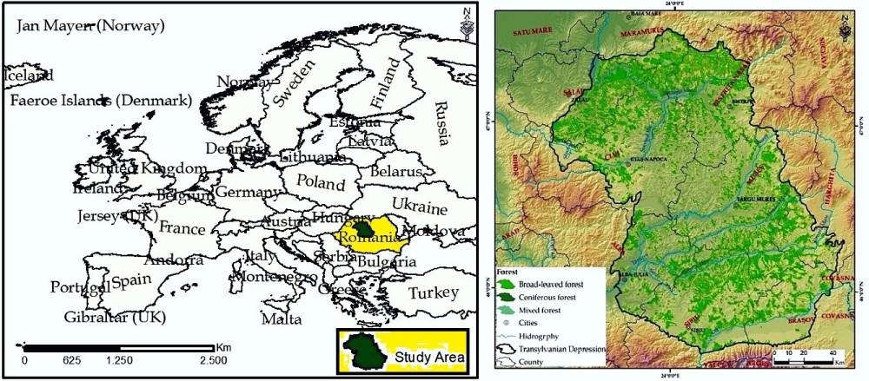
Figure 1. (Garamond Premier 10). Title of Figure 1 [no period at the end, e.g. Geographical position of the investigated area (according to Corine Land Cover, 2018)]. The titles of the tables and figures are written with Garamond Premier 10 and are indented both in the right and left with 1 cm. ‘Table x.’ and ‘Figure y.’ are bolded (but not in the text of the manuscript)
The footer of the figures (legend, explanation etc.) is written with Garamond Premier 9 and is also indented both in the right and left with 1 cm

Ethical issues
Make sure that you comply with the ethical standards in respect of patient rights, animal testing, environmental protection, etc. Mention relevant ethical considerations. If you used human subjects, did they consent to participate? If you used animals, what measures did you take to minimize pain? Interventional studies involving animals or humans, and other studies require ethical approval and it is mandatory to list the authority that provided approval and the corresponding ethical approval code.

Statistical analysis
Statistical methodology plays a critical role in the design of scientific studies, analysis of scientific data, interpretation of results and drawing of conclusive statements. Therefore, using appropriate statistics is one of the most important conditions in order to obtain adequate results and increase the impact of the scientific research. Describe any controls and the statistical procedures, respectively data analysis, statistical tests, software used, etc. Make sure that the statistical analysis is appropriate. Please check information and data regarding your statistical analyses, e.g.: the sample size (it should be appropriate); data meet the assumptions of the chosen test (statistical tests is appropriate for data with a normal distribution or not normally distributed); the used test was appropriate; the p-values were reported/mentioned in the text, figures and/or tables and accompany all statistical comparisons; the ‘Statistical Analysis’ sub-section should also state the threshold for accepting significance, such as “Values of P < 0.05 were considered statistically significant”. When data of variables are shown, check whether the data show mean ± SD or mean ± SE. Be careful, use standard deviations (SD) to describe the distribution of variables, but the standard errors (SE) of the means of the variables to describe a measure of accuracy of a statistic calculated on a sample.
Conventionally, ‘Materials and Methods’ section is considered as the most easily written section. However, nearly 30% of the reasons for rejection of the submitted manuscripts are related to this section. A well-written M&M section (and statistics sub-section) markedly enhances the chances of an article being published (Erdemir, 2013).

Other issues
Remember - authors should create headings that are brief and relevant, to break ‘Materials and Methods’ section into parts which will guide readers through the main points of their experimental procedures and work.

Sub-subsections
If sub-subsections are needed, use Garamond Premier 11, underline, no bold, no italic, one free line above.
The scientific denominations of plants, animals, insects (genus, species etc.) will be typed in italics. Names of cultivars/varieties have to be included within single quotation ‘…’ (never double quotation marks) e.g. Malus domestica cv. ‘Golden Delicious’. Ranks above genus (e.g. family, order, class) receive one-part names which are conventionally not written in italics.
Mathematical equations must be typewritten, with subscripts and superscripts clearly shown. The equation should be typed in the same format or in Equation Tools, and with its numeration in the right side, e.g.:

Y= a + bX | (1)

Spell out numbers one to ten, unless a measurement (e.g. four flowers, 5 g), but use 14 plots, 65 leaves, etc. Always use decimal points, not commas (0.4 not 0,4) and have a zero before a decimal point (0.5 not .5). Separate thousands with a comma (1,542 not 1 542, 1.542 or 1542). In vitro is spelled Italics.
Use standard SI units and abbreviations, respectively international system of dates (e.g.: s, min, h, d, µmol, m-2, µM, N, etc.), but use week, month, year, etc. in full text. Leave a space between a value and its unit(s) (e.g. 5.6 g, 16 m, 18.6 °C).
Please note:
-Use ‘.’ (not ‘,’) for decimal point: 0.6 ± 0.2; Use ‘,’ for thousands: 1,230.4.
-Use ‘-’ (not ‘–’) and without space: pp 27-36, 1998-2000, 4-6 min, 3-5 kg.
-Use spaces between value and measure unit/mathematical symbols: 5 h, 5 kg, 5 m, 5 °C, C : D = 0.6 ± 0.2; p < 0.001.
-Without space: 55°, 5% (not 55 °, 5 %).
-Use ‘kg ha^{–1}’ (not ‘kg/ha’).
-Use degree sign from ‘Insert Symbol’ (‘°’), with space after the temperature value: 5 °C (not 5ºC etc.).

Results

This chapter may be titled ‘Results and Discussion’ including both results and their discussion, as R&D chapter. However, it is recommended that ‘Results’ chapter be separately, as first one, and then, separately, the ‘Discussion’). As for ‘Materials and Methods’, the authors can divide this chapter (if necessary) in sub-headings, to break this part into sub-sections that are brief and relevant, which will guide readers through the main points of their results and/or discussion. Please provide a concise and precise description of the results based on your own data; if the section is combined as R&D, include after the presentation of the results their interpretation, as well as the experimental conclusions that can be drawn. Do not fabricate or distort any data and do not exclude any important data; similarly, do not manipulate images to make a false impression on readers. Such data manipulations may constitute scientific fraud.
The ‘Results’ section will be organized around tables and figures, which should be well sequenced to present the key findings in a logical order. All tables and figures must be mentioned in the main body of the article and numbered in the order in which they appear in the text (Table 1, Table 2 etc.; Figure 1; Figure 2 etc.). Try to write the text of the results section based upon the sequence of tables and figures. Figures should be placed in the main text near to the first time they are cited.
Present carefully the figures and tables. All table columns should have an explanatory heading. To facilitate the copy-editing of larger tables, smaller fonts may be used, but no less than 8 pt. in size. Avoid very large, complex tables. Plan each table so that as much information as possible is in a clear, succinct caption. The legend must include all explanatory data, to facilitate a good understanding for the readers. The results can be presented only in the tables, but please remember: “A figure is worth a thousand words”. Hence, except tables as major way to present your results, illustrations, including figures and/or pictures, represent one of the most efficient ways to highlight your results. Because your data are the driving force of the manuscript, your illustrations are critical. How do you decide between presenting your data as tables or figures? Generally, tables give the actual experimental more exhaustive or/and detailed results, while figures are often used for highlight some relevant comparisons of experimental treatments and variants, or for revealing some data and demonstrations.
The titles of the tables and figures (and the content, except some larger tables as it was mentioned above) are written with Garamond Premier 10. The title is indented both in the right and left with 1 cm and 'Table x.' and 'Figure y.' are bolded (but not in the text of the manuscript). The footer of the tables and figures (legend, explanation etc.) is written with Garamond Premier 9 and it is also indented both in the right and left with 1 cm.

Table 1. Title of Table 1 [no period at the end]. The titles of the tables, figures and the content, are written with Garamond Premier 10 and is indented both in the right and left with 1 cm. 'Table x.' and 'Figure y.' are bolded
Cultivar | Content, as mean ± S.E. (in g) |  | Total sugars/organic acids
 | Citric acid | Malic acid
‘Braeburn’ | 0.125 ± 0.009 abc | 8.59 ± 0.85 b | 16.41 ± 1.35 c
‘Jonagold’ | 0.147 ± 0.024 abc | 5.19 ± 0.23 c | 24.15 ± 1.31 b
‘Red Elstar’ | 0.230 ± 0.021 ab | 12.82 ± 0.64 a | 12.31 ± 0.61 d
‘Golden Delicious’ | 0.239 ± 0.021 a | 5.73 ± 0.26 c | 23.45 ± 0.95 b
‘Florina’ | 0.106 ± 0.012 bc | 5.02 ± 0.33 c | 28.88 ± 1.28 a
‘Goldrush’ | 0.049 ± 0.014 c | 13.33 ± 1.10 a | 13.42 ± 0.94 cd
‘Goldstar’ | 0.216 ± 0.017 ab | 13.06 ± 0.49 a | 14.45 ± 0.44 cd
‘Rubinola’ | 0.112 ± 0.020 abc | 7.05 ± 0.22b c | 21.27 ± 0.78 b
‘Topaz’ | 0.209 ± 0.026 ab | 12.05 ± 0.91 a | 13.61 ± 0.68 cd
Cultivars susceptible | A | A | A
Cultivars resistant | A | A | A
The footer of the tables (legend, explanation etc.) is written with Garamond Premier 9 and is also indented both in the right and left with 1 cm
*Notes (legend): include adequate data or explanation. E.g. Different letters between cultivars denote significant differences (Duncan test, p < 0.05). Different letters between susceptible and resistant cultivars denote significant differences (LSD test, p < 0.05).

Please provide adequate tables and figures with a short explanatory title and caption. Data presented in tables should not be duplicated in figures (or vice versa). Also, please check: clear title and legend, concise and clear explanation; results, data - information, measure units, alignment, adequate font - as in text - and size; verify O-X and O-Y axes of the graphs - their title, units, properly use of superscript and subscript if necessary, font and size, symmetry for combined figures, visualisation and understandable; adequate resolution and design for the figures, well design including as colours etc. Figures and/or photographs must be clear, with sharp focus and good density. Use a properly resolution of the figures and picture (minimum 1000 pixels width/height, or a resolution of 300 dpi or higher) in order to assure a nice design of your final manuscript. Common formats are accepted; however, JPEG is preferred. Consequently, include in your word submission (template) the figures as the best quality, clarity, and colour in JPEG format. If your original figures are too large to be included in the submitted manuscript (and you prefer do not resize them), you can include them in the files as supplementary materials in the submission process.
The authors are invited to prepare figures in colour, because there is no additional cost for colour publishing. In addition, send the figures in Excel, in order to facilitate our editing format. If in your manuscript there are one or more figures with high quality, design and significance for scientific content of the work, they can be used as a ‘Cover Image’ for your paper. Anyway, if your article is accepted for publication, you can submit a Cover Image idea (very high quality and resolution image), which can be used as a Front Cover Image. Usually, this raises the impact, visibility and article usage metrics and makes your work more visual and attractive.
Captions with figure numbers must be placed after their associated figures. If figures are grouped (e.g., several photographs or graphs, histograms etc., label each panel as A, B, C etc.), give a general title and describe each panel (A, B etc.) separately in the legend. Citation of these figures in the text is done as: Figure 1A, Figures 1B and 1C, Figures 2A-D etc.

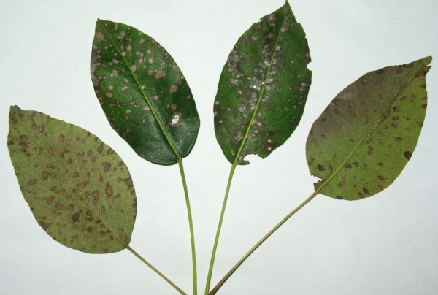 | 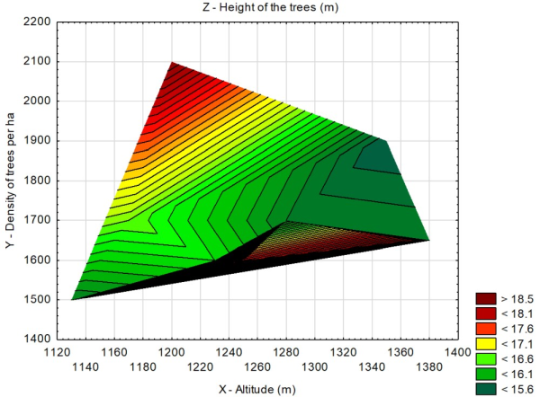
(A) | (B)
Figure 2. Title and explanation [no period at the end]. Title for general content of the figure, and then describe the different panels; (A) Description of what is contained in the first panel; (B) Description of what is contained in the second panel [no period at the end]
The footer of the figures (legend, explanation etc.) is written with Garamond Premier 9 and is also indented both in the right and left with 1 cm

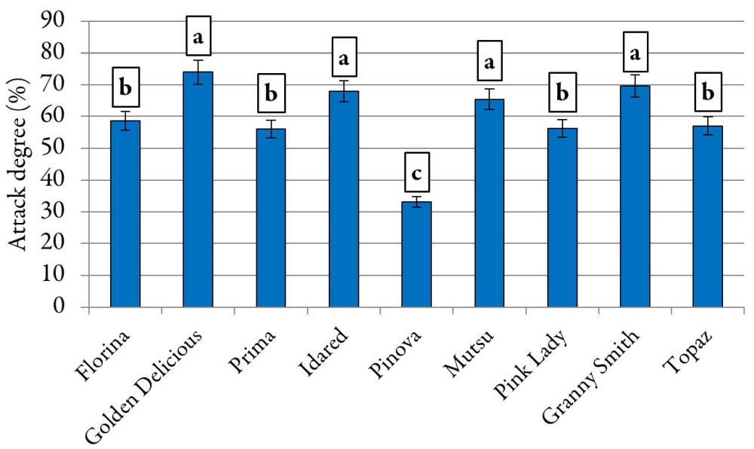
Figure 3. Title and explanation [no period at the end]
The footer of the figures (legend, explanation etc.) is written with Garamond Premier 9 and is also indented both in the right and left with 1 cm

Captions to tables and figures must be informative but not very long. At the same time, be careful that tables and figures’ legends contain the necessary information so that a person can understand all data. Each figure or table should be clear and self-explanatory! Use clearly name/description for each variant, or a legend. If similar data are presented in several tables or several figures, then the format of their captions should also be similar. Refer to “figures” instead of “graphs” or “charts”, and avoid making statements such as “Figure 1 shows...”. Instead, state “The most intense attack was recorded on the leaves (Figure 1)”. Not all results deserve a separate table or figure. As a rule of thumb, if there are only a few numerical results or a simple conclusion describe the results in the text instead of in a table or figure.

Supplementary material
Additional data and files can be uploaded as “Supplementary Files” during the manuscript submission process. The supplementary files will also be available to the referees as part of the peer-review process. Any file format is acceptable; however, we recommend that common, non-proprietary formats are used where possible

Journal requirements
Please do not forget the journal requirements: The papers will be (generally) written in an impersonal mode. On the other hand, you can use first person, especially in ‘Results’ section, but it should be used sparingly. Please reserve the use of first person for things that you want to emphasize that “you” uniquely did (i.e. not things that many others have done as well).
Results described in your paper should be described in past tense (you have done this experiment). Use the past tense for observations that took place in the past; reserve the present tense for generalizations. Be consistent in your use of tenses.

Discussion

General issues
The ‘Discussion’ section should not contain a repeat of the results, but should explain the meaning of the findings and places the results in the context of other studies and concepts. Generally, there should be at least 30-40 citations as related resources in introduction and discussion sections, in order to compare the obtained results with relevant and similar results from scientific literature, published before by other researchers. The citations (respectively references) in this section should be up to date, relevant for the study. Please explain here how the results relate to previous findings, whether in support, contradiction, or simply as added data. Answer your research questions (stated at the end of the introduction chapter) and compare your new results with published data, as objectively as possible. Try to refer to the limitations of the study or how your results compare to other studies, which were published recently. Discuss their limitations and highlight your main findings. Consider any findings that run contrary to your point of view. To support your position, use only methodologically sound evidence.
Highlight the most significant results explaining how these results are compared to the original question. Do the data support your hypothesis? Are your results consistent with what other investigators have reported? If your results were unexpected, try to explain why. Is there another way to interpret your results? What further research would be necessary to answer the questions raised by your results?

Citations - references
In all sections (especially in introduction and discussion), please avoid citing inaccessible data; do not include unpublished data; provide relevant, timely and accessible through ordinary library or academic databases. Although you may read some general background references, e.g. encyclopaedias, books, manuals, etc. it is recommended to cite articles from recognized research journals, which reported specific results relevant to your study. Remember to comply with the journal’s instructions to authors in respect of abstract length, citations, style of references, etc.

Conclusions

State only conclusions that are directly supported by the evidence and the implications of your findings, preferably in one-paragraph. Conclusion section summarizes the results and major findings; do not, however, include in the conclusion anything that has not been brought up in the results and discussion components. In addition, do not overgeneralize your conclusions. Avoid saying “in conclusion” or similar sayings. This includes “in summary” or “in closing”. These sayings usually sound stiff, unnatural, or ambiguous when used in writing. Moreover, using a phrase like “in conclusion” to begin your conclusion is a little too straight-forward and tends to lead to a weak conclusion. A strong conclusion can stand on its own without being labelled as an own uncertain supposition (e.g. due insufficient investigations, or an improperly evaluation of the own results in the context of other similar researches etc.).

Authors’ Contributions

The contributions of authors to the manuscript should be specified in this section; according to the type of contribution (choosing only the appropriate ones), the authors are mentioned by initials: Conceptualization (e.g. ‘Conceptualization: AB and CDE’ etc.); Data curation; Formal analysis; Funding acquisition; Investigation; Methodology; Project administration; Resources; Software; Supervision; Validation; Visualization; Writing - original draft; Writing - review and editing. Please note: Authorship must be limited to those who have contributed substantially to the work reported. Please add at the end: All authors read and approved the final manuscript.

Ethical approval (for researches involving animals or humans)

Interventional studies involving animals or humans, and other studies require ethical approval and it is mandatory to list the authority that provided approval and the corresponding ethical approval code. For research involving human research participants, authors must identify the committee approving the research, and include with their submission a statement confirming that informed consent was obtained from all participants.

Acknowledgements

Acknowledgements - quick thanks should be mention only to the fund providers or supporters. The recommended form is: “This work was supported by the …, grant number xxx”. If no specific funding was provided, use the following sentence: “This research received no specific grant from any funding agency in the public, commercial, or not-for-profit sectors.”

Conflict of Interests

A conflict of interest is a situation in which a person or organization is involved in multiple interests, financial or otherwise, and serving one interest could involve working against another. Authors must identify and declare any personal circumstances or interest that may be perceived as inappropriately influencing the representation or interpretation of reported research results. If no conflict exists, the authors can state “The authors declare that there are no conflicts of interest related to this article”. Any role of the funders in the design of the study; in the collection, analyses or interpretation of data; in the writing of the manuscript, or in the decision to publish the results must be declared in this section. If there is no role, please state “The funders had no role in the design of the study; in the collection, analyses, or interpretation of data; in the writing of the manuscript, or in the decision to publish the results”.

References

All citations mentioned in the text must be included in the ‘References’, which must be elaborated in alphabetical and chronological order; also, all references must be cited in the text. Each reference will be justified, hanging 1 cm, as in journal format (see below).
Check carefully the accuracy/correctness of all references! Try to use adequate references for your manuscript, using the most credible and up to date types of publications, especially peer-reviewed journals.
Authors cited should be listed for each reference in the following order: authors, year, title of the work cited, journal (as full title), volume, issue, pages (below, there are presented specific citations for different resources). When there are eight or more authors, include the first six authors’ names followed by an ellipsis (…) and the final author’s name. At the end of each reference, between the pages of articles cited, please use hyphen “-”, not dash (“–”).
The DOI (digital object identifier only as URL) number for the cited articles or resources must be included after references. If there is no DOI available, the stable URL can be used, but only with reference to the exact source, if any. If there is no precise and direct source on the Internet, it is not included.
Please do not use capital letters in references for articles’ title (do not use capital letters for common nouns, unless they start a sentence or are proper nouns, which are specific names or titles). Use properly common nouns and proper nouns by writing adequately the initial letter (capitalized only for proper nouns). Do not use a capital letter for a common noun (i.e., the word for something) unless it starts a sentence. For example: tree(s), flower(s), river(s) etc. Do use a capital letter for a proper noun (i.e., the specific name of something). For example: Nile Delta, Pacific Ocean, Malus domestica, Black Forest etc.). Use italics for scientific names, in vitro, etc.
Examples of written references style depending on the cited resources (in the prepared manuscript they will be included in a common list, in an alphabetical order), see below. For non-English publications, give the original title followed by its translation into English in square brackets, see below. Please verify and write journals titles carefully. Use full titles of the journals, not abbreviation.

(Journal Articles)
Anderson PT, Devi ZHT, Diggins T, Stanford Z, Stone V, Roth S, … Smith JB (2017). Nutrition analysis of cherry juice. Scientia Pomologica Journal 19:234-241. https://doi.org/10.7016/j.tnverpvoc.2010.102005
Brown GR, Marshall TK, Young G, Murray ST, Vinson BN, Wilkins HJ (2019). Conventional and alternative pre-harvest treatments affect the quality of pear fruit. Journal of Fruit Growing 32:135-144. https://doi.org/10.538/s41598-01237
Cooper V (2001). Flavonols of leaves in relation to apple scab resistance. Horticulturae Acta Journal 82(1):326-334. https://actahort.org/books/814/814_22.htm
Erdemir F (2013). How to write a materials and methods section of a scientific article? Turkish Journal of Urology 39(1):10-5. doi: https://ncbi.nlm.nih.gov/pubmed/26328129
Johnson BV, Miller CK (2020). Response to diseases attack of European (Pyrus communis L.) and Asian (Pyrus serotina Rehd.) pear cultivars. Fruit Trees Pathology 31:125-136. https://doi/abs/10.1111/ijfs.13339
Jones HG (2018). A multiple reverse transcription PCR assay for simultaneous detection of the main viruses in banana. Journal of Fruit Crop Diseases 123(4):28-39. https://doi.org/10.1016/j.scienta.2016.09.028
Kallet RH (2004). How to write the methods section of a research paper. Respiratory Care 49(10):1229-1232.
Pratt RC, Pullet VC, Boons BV, Carry TT (2011). Gene expression signatures involved in fungal diseases pathosystem in compatible and incompatible interactions. Horticultural Plant Pathology Journal 142(4):181-192.
Robbins MGL, Hoffmann DRT, Wang FV (2017). Anticarcinogenic flavonoids in different fruits commonly consumed. Plant Sciences Journal 40:2379-2383.
Smith D (2019). Biosynthesis of phenolic compounds and its regulation in pear. Journal of Biosynthesis 37(1):54-63.
(When there are eight or more authors, include the first six authors’ names followed by an ellipsis (. . .) and the final author’s name)

References in other languages than English
Höfer M, Flachowsky H, Hanke M-V (2019). Deutsche Genbank Obst - Rückblick auf 10 Jahre nationales Netzwerk für nachhaltige Erhaltung von obstgenetischen Ressourcen [German Fruit Genebank - looking back 10 years after launching a national network for sustainable preservation of fruit genetic resources]. Journal fur Kulturpflanzen 71(2/3):S41-51. https://doi.org/10.2073/JfK.2019.02-03.01
(For non-English publications, give the original title followed by its translation into English in square brackets)

References with doi or/and journals which use article numbers instead of page numbers
Bostok M (2015). Apple crop. In: Frank E (Ed). Organic apples. doi: https://link.com/article/10.1134/S207
Stanley A (2020). Foliar fertilization effects on plum. Horticulture Papers 12:424. http://dx.doi.org/10.145/97-42
Robson T, Kent KG, Pallor TR, Duvall D (2015). Comparative genome analysis provides insights into the evolution and adaptation of Erwinia amylovora on apple. PLoS One 6(3):e10228.

(Book)
Abbot MC (2014). Molecular cell biology. Academic Press (4th ed), San Diego.
Donovan B, Clarke P (2017). Apple breeding. London, Rutledge.

(Book Chapter)
Gibson JH (1999). Apples. In: Taylor K, Noon YT (Eds). Advances in fruit breeding. California University Press, West Lafayette, Indiana pp 3-37.
Smith S, Johnson T (2018). Health benefits of apple. In: Skipper T (Ed). Apple production. Frenches Press NSW Pearson Education Australia pp 281-299.

(Proceedings Paper)
Davey SD, Norris TG, Saylor JL (2014). Advances in cucumber fertility. In: Knorr VB, Sting F, Banner Y (Eds). Proceedings of the Society for Horticultural Sciences 2014 Conference. Sydney: Springer pp 113-119.
Simson AN, Wood SF (2015). Organic and integrated fruit production systems. In: Proceedings of the 12th International Symposium on Genotype-Ecotype Relationships. Springer, Dordrecht, Netherlands pp 312-334.

(Reports, web-sources)
Department of Agriculture (2019). German agricultural statistics for 2018. German Agriculture Department München. Retrieved 2020 February 12 from http://www.germanyagriculture.gov/projects
PCADPP (2018). Presidential Commission on Agricultural Development Public Policy. The National Strategic Framework for sustainable development of the agro-alimentary sector (in Romanian). Retrieved 2019 April 12 from http://www.presidency.ro/static.pdf

(Thesis or Dissertation)
Nemeth V (2016). Decision support systems for the evaluation and use of orchards. PhD Thesis, Corvinus Univ, Budapest.
Williamson JD (2003). Optimization of tissue culture techniques and Agrobacterium mediated transformation in barley. MSc Dissertation, University of Edinburgh.

